1: unzip the source code

put the kernel and device code in the same directory

A9500_source---kernel
c |-device

2: build code

Kernel:
make ARCH=arm CROSS_COMPILE=arm-eabi- a9500_htc_evm_defconfig
make ARCH=arm CROSS_COMPILE=arm-eabi- -j4

You will get zImage in arch/arm/boot
Note: you should build the kernel first

Device:
#source build/envsetup.sh
#lunch ste_u8500-eng
#make TARGET_BOARD=htc_evm -j4

lunch用法：http://www.lupaworld.com/home.php?mod=space&uid=131820&do=blog&id=149462

You could get images in out/target/product/u8500 of the source tree

Hboot:
make u8500

You will get hboot.nb0 in out/

3: burn image

I: Prepare your zip image , you can use the PG58IMG.zip as a example.
II:Put PG58IMG.ZIP on FAT32 format SD Card and plug it into device.
III:Boot to hboot mode(press the power and hboot key at the same time)
IV:The keymap is below

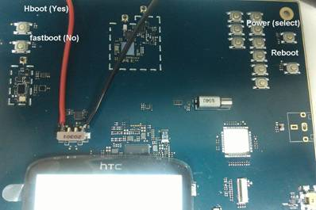

If you find hang here (loading), please try to boot to hboot again

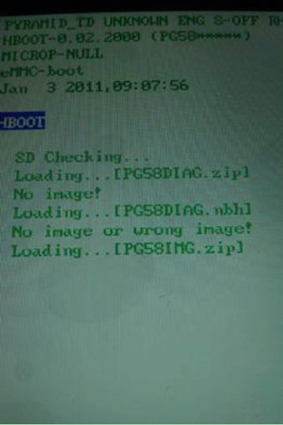

4: Generate the boot.img

If you want to use boot.img to burn kernel image, please generate it as boot.img first.
Get mkbootimg, ramdisk, here, and put the zImage on the same folder.

./mkbootimg --base 0x00000000 --kernel ./zImage --ramdisk ./ramdisk.img --cmdline "cachepolicy=writealloc noinitrd init=init board_id= crashkernel=cras
hkernel=1M@0x5600000 logo. startup_graphics= root=/dev/mmcblk0p15 rootdelay=1 console=ttyAMA2,115200n8 mem=128M@0 mem=40M@128M hwmem=28M@172M mem=24M@200M me
m_mali=32M@224M pmem_hwb=64M@256M mem=192M@320M" --output ./boot.img

5: Erase the flash and burn the hboot

if the hboot was broken or the flash was blank,you can burn the hboot by the follow step.

I: erase the flash

#sudo PYD-TD-flashkit/u8500/scripts/PYD-TD/run_erase_0x0-0xend.sh

and then plug the usb cable into the device(don't power up the device with power supply)

II: burn the hboot

#sudo PYD-TD-flashkit/u8500/scripts/PYD-TD/flash_complete_linux.sh

if it is failed,you can re-plug the usb cable and re-run the cmd.

Then you can burn image with hboot.

PS:you need install the JDK first.

